THE SCHRAM ACADEMY
CHENNAI

WORKSHEET 2020-2021

NAME: ………………………………… | DATE: ……………………
CLASS & SECTION: V………. | SUBJECT: ENGLISH

I. | Vocabulary  Hi! I’m Jake. We just moved in to our new apartment last week. Our family wanted some new furniture for our new house. IKEA the popular furniture store offered home furniture at an affordable price.Dad said “It’s the best place to shop and online shopping is really convenient during lockdown.” We all agreed. Mom suggested each one of us to choose a piece of furniture we wanted in our rooms. I’m sharing the pictures of the stuffs our family has selected. I want you to read the descriptions and name the furniture using the help box.  Bunk bed  Hammock  Recliner  Vanity  Windsor chair.  Tuffet  Bean bag  This looks like a sack. You sink in if you sit on it. It looks weird though! But our brother wants it.(Name it)  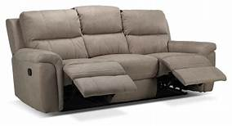This is what my parents want in the living room. They say it’s very cozy. They can sit, lie back, stretch their legs and watch Netflix together on Sundays. Hmm. Sounds good! (Name it )  This is a low seat with a cushion on top. Mom wants it right next to her low study. She has already ordered complementing curtains for her room. (Name it)  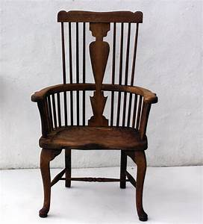Our granny is staying with us all through the shutdown, she loves antique and she wants something comfortable to sit on. Well! That makes sense.(Name it )  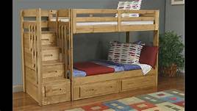 Hey! This is going to be in our room. Something excited to sleep on. I’m going to share this with my twin brother. I‘ve already decided what to put inside those drawers.(Name it )  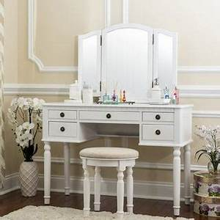 I’m not so happy to introduce this. This is for our sister to keep her things. Its extravagant .She always gets what she wants. Dad’s girl!(Name it )  Finally, something that all of us love to have in our garden. It’s portable. we can take it along whenever and wherever we want.(Name it )  Jake used some difficult words in his narrative. Use a dictionary to explore the meanings for the words underlined.  1. Word Meanings.  2.  3.  4.  5.  6.  7.  8.

