ENGLISH READING : Colour the picture

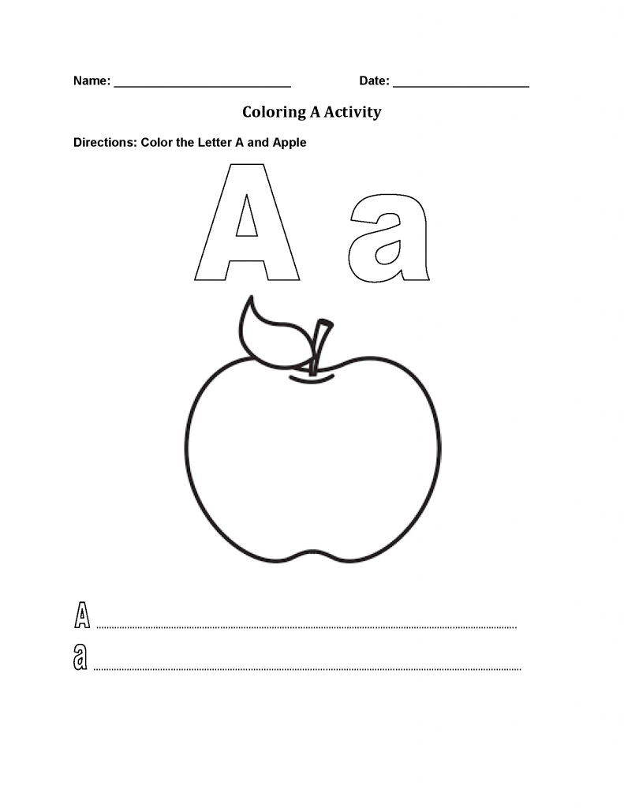

ENGLISH WRITING WORKSHEET (use crayons/pencil)
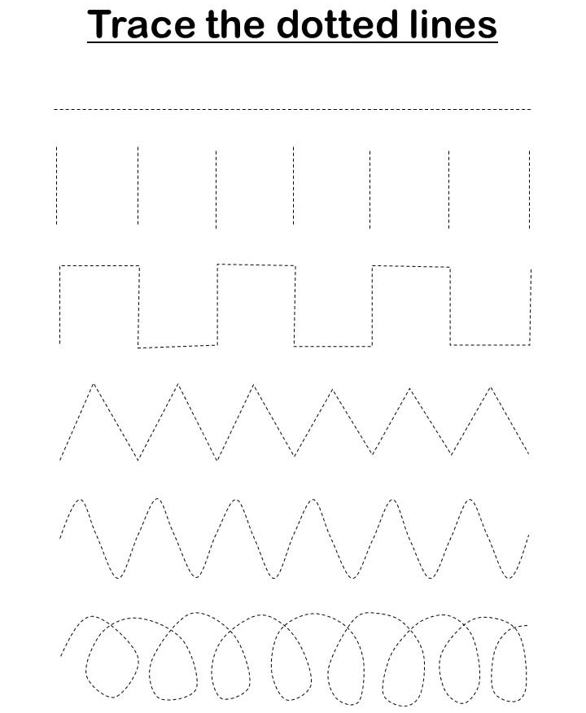
MATH(activity)
Stick colour paper according to shape colour
(paper tearing)

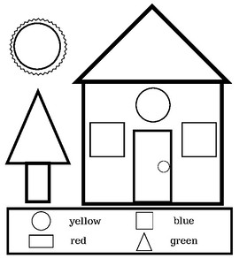

NATURE TALK (COLOUR & STICK PHOTO)