THE SCHRAM ACADEMY
SKG - SHORT STORIES – 2020

1.The boy who cried wolf
There was once a boy who kept a watch over the village sheep. He would often become bored and he will simply call out, “wolf! wolf,” although there was no wolf about.
The villagers would stop what they were doing and run to save the sheep from the wolf’s jaw. But once they arrive, the boy would just laugh. The naughty boy played this joke over and over again until the villagers grew tired of him.
One day while the boy was watching the sheep, the wolf really came into the field. The boy cried and cried, “Wolf! Wolf!”
But no one came to help him; they thought he was telling lies and the wolf had a feast of the sheep that day.
Moral: Do not tell lies.

2.Mother camel and a baby camel

One day, a camel and her baby were chatting. The baby asked, “Mother, why do we have humps?” The mother replied, “Our humps are for storing water so that we can survive in the desert”.

“Oh”, said the child, “and why do we have rounded feet mother?” “Because they are meant to help us walk easily in the desert. These legs help us move around in the sand.”

“Alright. But why are our eyelashes so long?” “To protect our eyes from the dust and sand. They are the protective covers for the eyes”, replied the mother camel.

The baby camel thought for a while and said, “So we have humps to store water for desert journeys, rounded hooves to keep us comfortable when we walk in the desert sand, and long eyelashes to protect us from sand and dust during a desert storm. Then what are we doing in a zoo?”The mother was dumbfounded.

Moral: strengths, skills, and knowledge are useless if you are not in the right place.

3. A Cricket and an Ant
Once there was an ant. She lived in a field. A cricket lived near the ant’s hole. They were friends. The cricket was lazy. In the months of summer, it sang and made merry. It did not store food for winter.
It was careless. The ant was not lazy. She worked all day and night. She gathered grains for winter. In winter, the ground was covered with snow. The cricket had nothing to eat. The ant had grains to eat.
The cricket went to the ant to borrow some grains. The ant asked, “What have you been doing during summer?” The cricket replied that it sang and made merry during summer. The ant replied, "If you sang the summer away, you should also dance the winter away " Sorry, I cannot giveyoufood.
Moral: No pains, no gains.

4. Classy Kitten
One day little kitten named Classy wandered into the forest near the village. As she was walking around, she saw a wolf.
“Hello, Mr.Wolf. I am Classy. I would like to be your friend,” Classy said to Wolf. But wolf just laughed, and said, “Ha! Ha! Ha! Who wants to be friends with such a small cat?” wolf walked away. Poor Classy was so sad that she just sat there under a tree.
After some time, a leopard came that way. ‘Perhaps I can be friends with him,’ thought Classy. “Hello, Mr.Leopard. I am Classy. I would like to be your friend,” she said. “Ha! Ha! Ha! I don’t want to be friends with the wee kitten,” the leopard said.
He walked to a pond nearby to drink some water. Classy was about to leave, when she saw someone hiding behind a bush near the pond. It was a hunter. He was aiming his gun at the leopard! Classy slowly crept up to the hunter, and scratched his leg.
“Ah” cried the hunter and jumped up. The leopard saw the hunter suddenly running for his life and was confused. Classy told the leopard what had just happened. The leopard thanked Classy for saving his life.
“I am Sorry. I will never make fun of you anymore, “said the leopard. They became good friends too.
Moral : Size does not matter.

5. The Tortoise And The Bird
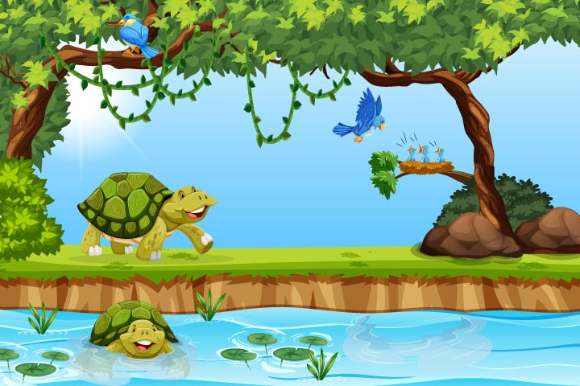
A tortoise was resting under a tree, on which a bird had built its nest. The tortoise spoke to the bird mockingly, “What a shabby home you have! It is made of broken twigs and has no roof. What’s worse is that you had to build it yourself. I think my house, which is my shell, is much better than your nest”.
“Yes, it is made of broken sticks, looks shabby and is open to the elements of nature but I built it, and I like it.”
“I guess it’s just like any other nest, but not better than mine”, said the tortoise. “You must be jealous of my shell, though.”
The bird replied. “My home has space for my family and friends; your shell cannot accommodate anyone other than you. Maybe you have a better house. But I have a better home”, said the bird happily.

Moral: Better a crowded hut than a lonely mansion.

6. The Sun and the Wind
It was an autumn day. The wind and the sun had an argument.
The wind boasted "I am stronger than you."
The sun mildly said "No. you are not".
Just then, they saw a traveller wrapped in a blanket was passing by. The wind said, "Whoever separates the blanket from traveller is the strongest. Do you agree?"
The sun replied, "OK. First you try."
The wind started blowing. The traveller wrapped his blanket around him. He blew harder. The traveller held his blanket firmer. He blew still harder. The traveller held his blanket still tighter. The harder the wind blew the tighter and firmer did the traveller hold his blanket. The wind failed.
It was the Sun's turn. The sun smiled gently at the traveller. The traveller loosened his grip on the blanket. The sun smiled warmly. The traveller felt the warmth and soon took off the blanket.
The sun was declared stronger.
MORAL : A gentle smile can achieve what brutal force can't.

