THE SCHRAM ACADEMY
CHENNAI

WORKSHEET 2020-2021

NAME: ………………………………… | DATE: ……………………
CLASS & SECTION: III……………… | SUBJECT: ENGLISH

READING
RAINBOW COLOURS 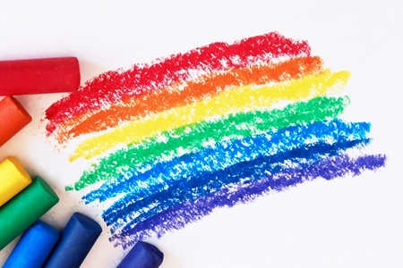
Seven little crayons all standing in a line .
They said, “let’s draw a picture and make it mighty fine.”
Red jumped for joy as he leaped across the sky.
Orange jumped up too, but not quite so high.
Next came yellow as bright as the sun. .

Green was excited as he started to run.
Blue followed boldly, then looked all around.
Indigo danced close to blue and made a nice curve.
Violet came last, nearly touching the ground.
“Isn’t this lovely?” the crayons exclaimed
“We’ve made a rainbow without any rain!”

- Which crayon jumped the highest?
- Name the third colour from the top.
- “Green was excited as he started to run”
What do you do when you get excited?

- Imagine and draw your own rainbow and give it your own colours.

- Read the sentences and draw a colourful monster’s face!
- Draw a big circle for a face
- Three green eyes.
- A purple nose.
- A pink and red mouth.
- Six blue ears.
- Colour the face yellow.
- Draw some colourful hair.
- My monster’s name is: _ _ _ _ _ _ _ _ _ _ _ _ _ _ _

- If you had 25 packets of crayons with 7 crayons in each pack, how many crayons would you have in all?

- Mention any 2 ways to reuse your broken crayons.

- Name your favourite crayon colour.

- When you mix red and yellow you get _____________

- Can you give examples for the following colours? First one is done for you.

- white – snow

- blue

- green

- red

- golden

Do you know the favourite crayon colour of the USA is blue?!

