THE SCHRAM ACADEMY
CHENNAI

WORKSHEET 2020-2021

NAME: …………………… | DATE: ……………………
CLASS & SECTION: III | SUBJECT: ENGLISH

Writing
Beyond question:
Questioning is a powerful tool that make you seek and learn new things!
Given below is a user manual of how to frame” Wh”questions.

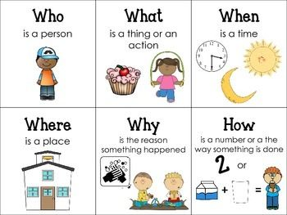

Fill in the following with the correct’ Wh‘word.

1.______ is that boy?
He is my brother.

2.______ is the birthday celebration?
Tonight at seven.

3._________on the table?
There’s is a pencil.

4. ______are you late to school?
I missed the bus.

5._______is your book? 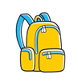
It is in my bag.

6.______do you go to school?

I go to school by car.

7._____is the park?
It is next to the library.

8.____is your brother crying?
His toy is broken.

