THE SCHRAM ACADEMY
CHENNAI

Worksheet 2020-2021

NAME: ………………………………… | DATE: ……………………
CLASS & SECTION: III ………. | SUBJECT: EVS

My family
I Find the family words in the grid below:
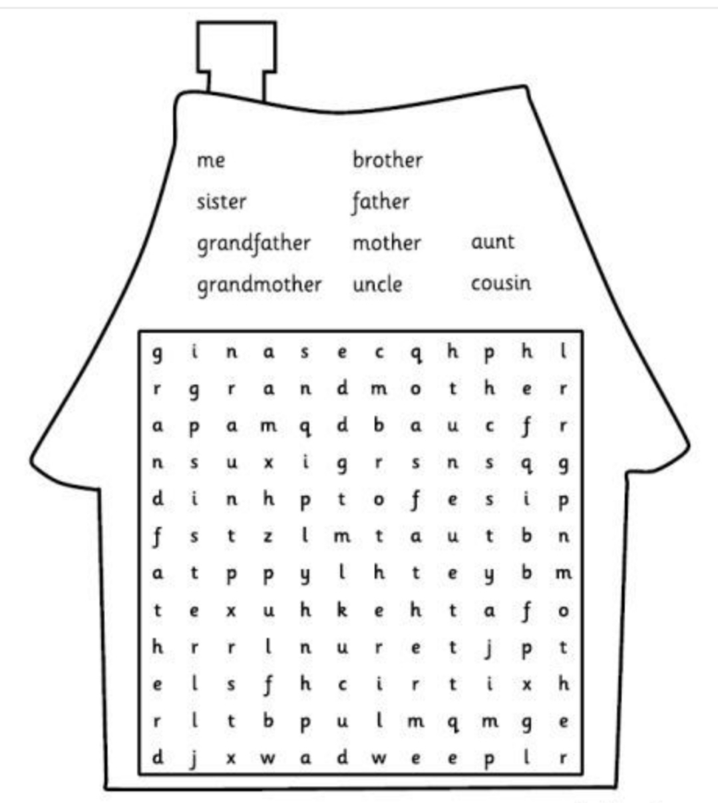Instructions: Words may appear horizontally (-), vertically (|) and diagonally(\)
II Know your family members:
S.no | What to find | Your findings
1 | Date of birth of your maternal grandparents.
2 | Date of birth of your paternal grandparents.
3 | Relatives born before 1970.
4 | Relatives who were born in a different country.
5 | Twins in your family.
6. | Relatives born after 2010.
7. | Do you live in a joint family or a nuclear family?
8. | Who do you resemble in your family?

III Journey in Candy Land
Rules to complete the Candy Land journey
Stand at Start
Jump 1 step forward and identify the person. How do you help that person.
………………………………………………………………………………………………………………………..
Jump 3 steps and find the relation. Name the favorite story told by them.
…………………………………………………………………………………………………………………………
Jump 3 steps. Draw a toy that you would like to play with that person.
………………………………………………………………………………………………………………………..
Jump 1 step back and find the relation. Write one good quality that you learnt from that person.

…………………………………………………………………………………………………………………………
Jump 4 steps forward. Write a present you received from them.
…………………………………………………………………………………………………………………………
Jump 3 steps ahead and find the relation. Draw a gift that you would like to give to that person.
………………………………………………………………………………………………………………………….
Jump 2 steps forward and find the relation. Write one present that you received from that person.
…………………………………………………………………………………………………………………………
Jump 1 step back and write the name of the month we celebrate Grandparents day in India.
……………………………………………………………………………………………………………………….

Make your Candy Land more colorful by drawing candies in all the empty boxes and colour it.

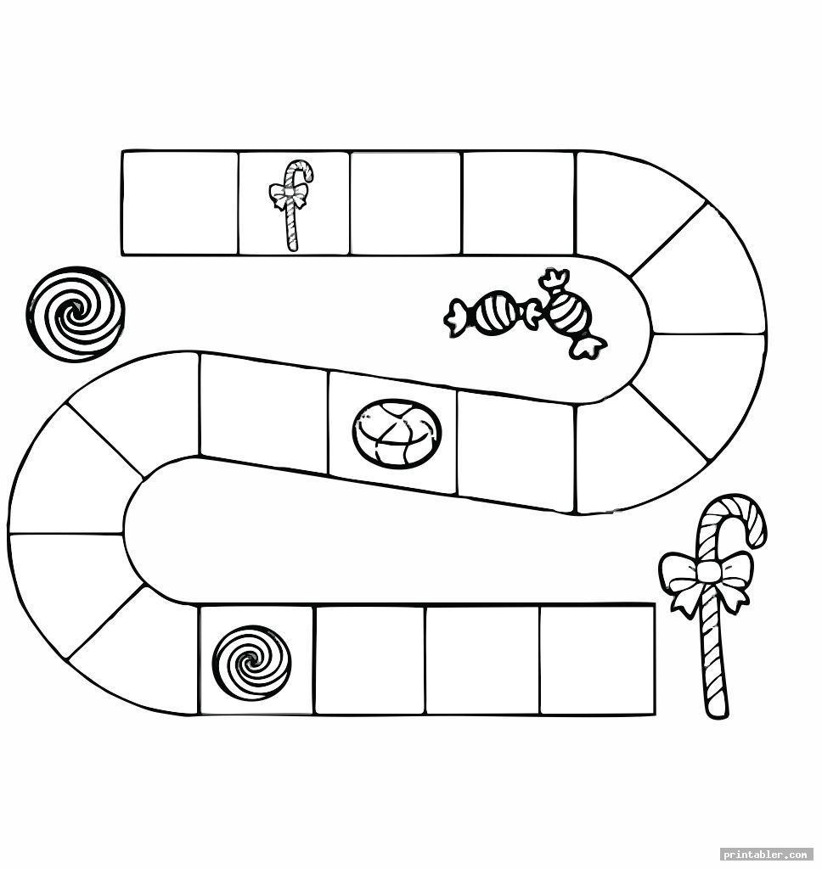
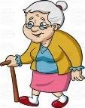
Mother’s
sister
Head of
family
Father’s
brother
- Word chop puzzle:
Refer to the given word chop table and find out the hidden family members:

grand  1 | sibl  2 | fath  3 | Ings  4
Tw  5 | cous  6 | unc  7 | Le  8
moth  9 | ter  10 | er  11 | Ins  12

- The children of your aunt and uncle 6, 12(cousins)
- Mother’s mother 1,9,11
- Father’s brother …………..
- Mother’s father ……………
- Children of same parents ……………
- Two children born at a same time to a same mother ……………

- Table here shows you the generations in a family. Add the names of the family members from the box to the correct space in the table.

Generation 1
Generation 2

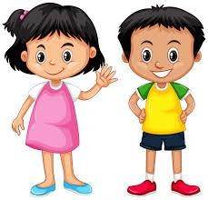

Generation 3

Uncle
Grandfather
Cousin
Aunt
Brother
Mother
Grandmother
Sister
Father

